DE-RISK – STANDAR CALL OUTLINE PROPOSAL TEMPLATE

PROPOSAL TITLE
PRIME COMPANY
COUNTRY
ENTITY CODE (if any)
POINT OF CONTACT (email and phone number)
DE-RISK BUDGET (k€) [for De-risk Portfolio option max 50k €. For De-risk Technology activities max 250k €]

This template is applicable to the De-risk Technology and De-risk Portfolio activities, please select the applicable option deleting the not applicable parts.

The acceptance of this outline proposal is not related with any future activity commitment.

This template must be used as it is without any change in the formatting, logo of the bidder is accepted only on the first page, no subparagraph shall be added.

Please remove all descriptions in red

- TECHNICAL PROPOSAL

  - Application(s) of the Full Activity Development (i.e. De-Risk and Follow-On Phases)

Please describe the targeted product(s), capabilities and applications that are linked to the technical objectives. Please provide indications with respect to the targeted mission(s) and/or market (e.g. the size of the addressable market, bottom-up market analysis), customers, potential interest of customers, competitors (European and non-European), strategic relevance of the development for the bidder and the potential differentiating advantage of the product to be developed with respect to the state-of-the art. Also, discuss the expected benefits of the proposed activity to your company/institution. If the application is pertinent to an ESA Programme(s), please identify which programme/project would be relevant to your proposal and indicate how this activity may contribute towards this opportunity.

……………

  - Technical Objectives and Requirements of the Full Activity (i.e. De-Risk and Follow-On Phases)

Outline the main technical objectives of the proposed full activity (de-risk and follow-on) and the proposed approach to reach them. Identify and discuss the technical requirements to be able to achieve the specific technical objectives. When appropriate the requirements shall be associated to a quantitative value. These quantitative values shall be labelled as committing ones or should be considered as goals. The verification approach for each requirement shall be identified. Please discuss how these objectives will help to meet the longer-term objectives for the targeted application area where the technical objectives will have an impact.

……………

  - Technology Readiness Level and Model Philosophy of the Full Activity (i.e. De-Risk and Follow-On Phases)

Identify and justify the starting Technology Readiness Level (TRL) and the TRL to be reached at the end of the full proposed activity. Discuss the next steps in terms of objectives and future targeted TRL, assuming the objectives are achieved at the end of this activity.
The final deliverable of the complete development (activity and next steps) should be a product, describe the model philosophy (e.g. EM, EQM, PFM, etc.).

(Please note that TRLs are defined as per ECSS-E-HB-11A “Technology Readiness Level Guidelines”; http://www.ecss.nl).

……………

  - Technical Steps and Implementation of the Engineering Approach for the full activity (i.e. de-risk and follow-on phases)

Present and discuss in detail the scientific/technical steps to achieve activity objectives and the committing requirements outlined in section 1.2 (Note: the steps shall be consistent with those reflected in the Work Logic flow-chart in section 1.6.2. of this document).

Present a first iteration of the concept and the baseline design/approach. The baseline design covers for instance the system architecture and a functional decomposition presented in block diagrams, providing also internal and external interfaces. Discuss the current state of the art and the trade-offs that need to be taken into account. Discuss how the work performed will be validated and how achievement of the objectives will be proven/demonstrated. Include a requirements verification matrix (consistent with the requirements identified in 1.2).

……………
  - Identification of the Main Problem(s) or Problem Area(s) and proposed Risk Mitigation Actions/Solutions to the Problems identified

Identify the full activity (i.e., De-risk and Follow-on phases) risk and risks analysis, including an impact/likelihood chart. Propose mitigation and preventative actions to reduce the likelihood and potential impact of such risks/problems and discuss credible alternative design or implementation solutions to avoid identified potential technical problems becoming showstoppers.

Identify the risk to be addressed during the de-risk phase, highlighting how the de-risk phase could reduce the total risk level of the activity.

……………

Risk Identifier | Description | Likelihood | Severity | Mitigation Actions
……… | ……… | low/medium/high | low/medium/high | ………
……… | ……… | low/medium/high | low/medium/high | ………
……… | ……… | low/medium/high | low/medium/high | ………

  - Technical Implementation/Programme of Work for the De-risk phase

The sub sections below are not applicable for activities under the De-risk Portfolio and to be disregarded.

The scope of the De-risk Portfolio is the preparation of the Development Plan and Business Plan for the Follow-on phase. No technology development is foreseen.

    - Proposed Scope and tasks for the De-risk Phase

This sub-section is not applicable for activities under the De-risk Portfolio activities and to be disregarded.

Describe in detail the scope of the De-risk phase; specify quantitative figures such as requirements and specifications, identifying specific and measurable goals and verification means in order to verify de-risk successful completion (e.g. requirement matrix with verification).

Present and discuss the technical steps and the committed requirements to achieve activity objectives.

Provide evidence as to the feasibility of meeting the objectives and requirements identified and assess technical problem areas and key development risks that may be expected during the execution of the activity.

    - Proposed Work Logic for the De-risk phase

This sub-section is not applicable for activities under the De-risk Portfolio activities and to be disregarded.

Present a first iteration of the proposed concept and the baseline design/engineering approach. The baseline design covers, for instance, the system architecture and a functional decomposition presented in block diagrams, providing internal and external interfaces.

Discuss the current state of the art and the trade-offs that need to be considered and show the overall logic of the work being proposed including any key review and decision points. Discuss how the work performed will be validated and how achievement of the objectives will be proven/demonstrated.

……………

    - Work Breakdown Structure (“WBS”) for the De-risk phase

This sub-section is not applicable for activities under the De-risk Portfolio activities and to be disregarded.
[As a rough guideline, Bidders are invited to consider including no more than 5 Work Packages.]

[For the total scope of the activity, clearly showing each foreseen Work Package (“WP”) with its title and the name of the responsible company/institute.]

Present a Work Breakdown Structure clearly showing each major Work Package (WP) with its title and the name of the responsible company/institute. Ensure work packages are split adequately such that sub-contracted work has its own work packages. Main contractor and subcontractor project management activities shall be identified in the WBS.

……………

Example:

The figure below presents the WBS, covering the entire scope of the proposed work.
Replace the following diagram with an equivalent showing the proposed work breakdown structure. Entries in the table are just examples to be amended as relevant.

Figure F.2 Work Breakdown Structure (*)

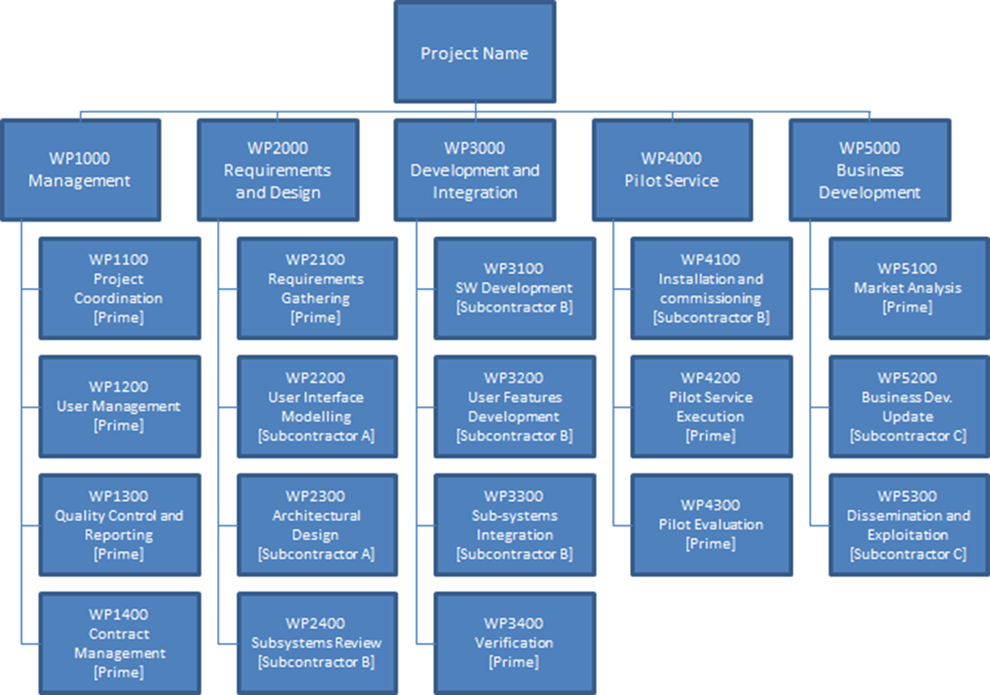
(*) The diagramme above is an example generated via the Excel Workbook “BA AO10494 MSP-PSS Tool”, which can be used by the Tenderer as described in the introduction. In case of use of the tool, this table shall be replaced with the corresponding element generated by the Tool in the Word documents at the output.

    - Work Package Description (“WPD”) for the De-risk Phase

This sub-section is not applicable for activities under the De-risk Portfolio activities and to be disregarded.
[For each WP already shown in the WBS: WP Title, Name of responsible company/institute, Name of the WP Manager, Input required to start the work under the WP, Output expected and a description of the tasks included in the WP. Please use the ESA PSS A20 form or an equivalent template, available at https://esastar-publication.sso.esa.int/supportingDocumentation.]

……………

Example:

A work package description form (PSS-A20) is presented herewith below for each of the work packages at the lowest level of the work breakdown structure. In general, in case the WBS is based on two levels WPs, the WPDs will refer only to the second level WPs, and the first WPs will not be associated to any WPD.

The work package descriptions comply with the following requirements:

- There is a single work package manager for each work package, who is a member of the key personnel.
- Work packages start and end on milestone events and do not span the entire duration of the activity (except for the project management work package and the closely associated management functions).
- Inputs from other work packages are clearly identified.
- The work to be performed is described in sufficient detail for the Agency to be able to judge the value for money, including scope of work and man-hours.
- Each task is traceable with a corresponding work package output.
- Each work package has at least one traceable work package output (hardware, software and/or documentation item, deliverable to the Agency).
- All deliverable hardware, software and documentation items are traceable to the identified work packages.

Provide completed work package descriptions for each work package identified in the work breakdown structure. Entries in the table are just examples to be amended as relevant
PROJECT: Project Name PHASE: N.A. | WP: 1100
WP Title: Pr. Management  Company: Prime  WP Manager: Project Manager Name  Start Event: KOM Planned Date: To  End Event: FR Planned Date: To+24m | Sheet 1 of 1  Issue Ref …  Issue Date …
Inputs:
- Project Proposal
- Management Requirements for Demo Projects
…

Tasks:
- Coordinate activities with Subcontractors
- Liaise with ESA
- Quality Control of Deliverables
…

Outputs:
- Minutes of Review Meetings
- Monthly Progress Report
- Project Web Page
- Final Report
- Summary and Achievements
…

(*) The form above is an example generated via the Excel Workbook “BA AO10494 MSP-PSS Tool”, which can be used by the Tenderer as described in the introduction. In case of use of the tool, this table shall be replaced with the corresponding element generated by the Tool in the Word documents at the output.

[For the total scope of the activity, clearly showing each foreseen Work Package (“WP”) with its title and the name of the responsible company/institute.]

Present a Work Breakdown Structure clearly showing each major Work Package (WP) with its title and the name of the responsible company/institute. Ensure work packages are split adequately such that sub-contracted work has its own work packages. Main contractor and subcontractor project management activities shall be identified in the WBS.

……………

PART 2 MANAGEMENT PART

2.1 Background of the company (ies) and facilities

Present an overview of the companies which will constitute the consortium including sub-contractors if any. Briefly describe the relevant experience for the Sub-contractor(s), if any, for the performance of their work.

Identify the facilities (including s/w tools) required to perform the proposed work. Submit a brief description of the intended facilities to be used, making it clear how the rights to use those facilities has been secured for this activity (e.g., own facilities, to be bought, to be constructed, sub-contracted, rented…).

2.2 Planning for the De-risk phase

Present a planning for the proposed activity, covering from the start of the de-risk activity until the end of the Contract, and including the major reviews and meetings.

2.3 Long lead time impacts

Please clarify whether the 9 months activity duration could be affected by long lead times (e.g. long lead item procurement, manufacturing, test, etc.). Indicate the reason for long leading times, the possible impact, the likelihood and possible countermeasure or mitigation actions.

PART 3 FINANCIAL PART

Total cost of the de-risk phase

Present the total cost of the de-risk activity and its breakdown by major cost elements (i.e. manpower, procurements, external services).

3.2 Estimated cost of the follow-on phase

Estimate the cost foreseen after the completion of the de-risk phase, in order to achieve the objectives indicated in section 1.2. Please recall the objectives and the target final TRL of the de-risk follow-on phase. Please provide an explanation for the estimated costs.

This information is not binding in any way for either party (ESA or Tenderer).

3.3 Further steps (after the follow-on phase)

In Case at the end of the follow-on the target TRL is below TRL 7 (or TRL 8 if an in-orbit demonstration is foreseen), identify each of the main development steps/activities that would be needed AFTER COMPLETION OF THE FOLLOW-ON to progress the work to the full maturation. Include a brief description of each step (e.g. key objective, aspects to be addressed). A cost to completion is required for these activities. This information is not binding in any way for either party (ESA or Tenderer).

In Case at the end of the follow-on the target TRL is 7 (or TRL 8 if an in-orbit demonstration is foreseen) this paragraph shall be not filled.

3.4 Estimated cost per step of the follow-on phase and further steps

Provide a summary of the rough estimate cost of each further step or activity that would be needed in order to reach the final TRL.

Further Step / Activity | Estimated cost (Euro) | Estimated Start date | Estimated end date

